**Increasing Visitor Engagement and Learning in Museums through Interactive Data Visualizations:**

**A Case Study at Black Creek Pioneer Village**

Laura Bandi

PSYC 6135: Psychology of Data Visualization

Dr. Michael Friendly

May 17, 2024

**Increasing Visitor Engagement and Learning in Museums through Interactive Data Visualizations:**

**A Case Study at Black Creek Pioneer Village**

Museums play a crucial role in preserving historical artifacts, information, and stories, as well as providing educational experiences to the public (Scott, 2006). However, the traditional museum setting relies heavily on static displays with textual information (Srinivasan et al., 2009). This can limit visitor engagement, experience, and learning, as these types of displays may not adequately capture visitor attention or cater to diverse learning styles among visitors. Recent advancements in immersive and adaptive technology offer innovative ways to enhance and modernize the museum experience. By integrating dynamic data displays or visualizations, museums can create more engaging exhibits that not only better attract visitors, but further their understanding and retention of the information being presented (Chen et al., 2021; Pallud, 2017). The proposed study aims to evaluate the impact of incorporating these interactive technologies for data visualization on visitor engagement, learning, and experience within the history museum setting at Black Creek Pioneer Village (BCPV). This study will provide valuable insights for future exhibit design at BCPV, as well as how interactive data visualizations may be implemented in other museum settings.

**Literature Review**

**Modern Museum User Experience and Engagement**

Recent research in the museum studies area has emphasized user experience (UX) in museum settings, in part due to the growing demands of the ‘experience economy’ (Pine & Gilmore, 1999; Roussou & Katifori, 2018). These findings indicate that utilizing technology to shape the museum experience and enhance exhibits for visitors can significantly increase their satisfaction and learning. UX in museums generally involves many moving pieces, such as the physical layout of the museum, ease of accessibility, availability of information, interactivity, and ambiance of the specific exhibit and museum (Mason, 2020). Research in this area demonstrates that those museums that prioritize UX tend to have greater visitor satisfaction rates and educational outcomes. This enhanced experience comes about when the physical and digital components of a museum are integrated to create a cohesive ‘set of experiences’ for the visitor (Mason, 2020; Norman, 2009).

**The Role of Technology in Enhancing the Museum Experience**

Advancements in technology have created many new opportunities for museums to interact with and engage their visitors. Virtual Reality (VR) technology has been used to reconstruct historical landscapes, create a museum experience for those off-site, and create tailored immersive learning experiences for museum patrons (Bruno et al., 2010; Kang & Yang, 2020; Pantile et al., 2016). Entire museum catalogues have been digitized and recreated completely online so those who cannot physically visit the museum can still use the museum as a resource to learn (Kang & Yang, 2020). Augmented Reality (AR) is also often used to overlay the physical space of the museum with further digital content (Bekele et al., 2018; Trunfio et al., 2020). Findings in this area suggested that the incorporation of immersive VR technology into museum settings significantly influenced visitor experience and satisfaction with their visit (Trunfio et al., 2020).

Simple and complex data visualizations have newly been proposed as a way to incorporate technology into the museum setting and make learning more engaging for visitors. Data visualization and museums work together three-fold: 1) museums often wish to convey information from large datasets, in which data visualizations can help make this data more intuitive for an audience to understand, 2) museums cater to a broad audience and data visualizations can be tailored to audiences of varying backgrounds, and 3) data visualizations can help museums modernize and keep up with the increasing demand for data use and transparency in museum settings (Mailhot, 2021). Mailhot (2021) has a clear focus on natural history museums, but I will go on to propose a study exploring how these principles of data visualization use in museums can easily be translated and applied to the heritage museum setting.

**Study Proposal**

**Setting and Background**

Black Creek Pioneer Village (BCPV) is an open-air heritage museum located in the North York neighbourhood of Toronto, Ontario, Canada. Established in 1960, the objective of this museum is to recreate what rural life in Ontario was like in the mid-late 19th century. Heritage buildings from that period from all over Ontario were brought to location, including an inn, schoolhouse, general store, blacksmith, church, family homes, and so forth. The historical accuracy flows through the breeds of farm animals that live at the museum and the plant varieties grown. Costumed interpreters can be found around the museum, acting out a certain role depending on which building they are working in and educating visitors about what daily life would look like in that role. Despite the clear value in historical content, BCPV has had trouble getting visitors, particularly young ones, excited, engaged, and motivated to return to the village.

During my time working at BCPV, I fielded many suggestions and complaints from frustrated visitors. Some common complaints raised by patrons include:

1. **Lack of Interpreters:** Unless there is a special event occurring or it is a holiday, only 3-4 interpreters work at a time. This leaves many buildings unattended and thus, unengaging, and difficult to learn about.
2. **Overreliance on Contextual and Textual Information:** When a building is unattended, visitors are left to simply look around the building and piece together their own narrative based on what items are in that building. Very few buildings even have plaques explaining what the items are and/or what the building’s purpose was and what activities would have occurred there.
3. **Disconnection to Modern Learning and Information Sharing:** Many visitors suggested that the dedication to being a live history museum has resulted in an outdated visiting experience. There is a distinct lack of technology being used to convey information. This is particularly felt by younger audiences, who have grown accustomed to receiving new information via some sort of technology.

Combining my love and knowledge of BCPV with my love and knowledge of the psychology of learning and data visualizations, I have come to believe that incorporating interactive data visualizations into BCPV would help to manage some of these common concerns, improve learning outcomes, and increase visitor engagement.

**Proposed Interactive Data Visualizations**

There are several specific interactive data visualizations that I will pilot in the proposed study, beginning with the following five ideas that I believe will have the greatest impact on learning outcomes and visitor engagement:

**3D Interactive Map**. Moving away from a simple paper map, a 3D interactive map will allow visitors to explore and understand the layout of BCPV before entering the museum (see Figure 1). Users will be able to navigate through different areas on the map to see detailed visualizations and descriptions of each building. This will help visitors better understand the geography of the outdoor museum. Visitors will also be able to plan their routes, gauge walking distances, and identify buildings and sites of interest, assisting them in tailoring their visit to their specific needs. Interactive elements will include clickable icons for each building, pop-up information windows about each building, animated transitions, and responsive zoom that guide users through the village.

**Figure 1.** *Current BCPV Paper Map vs. 3D Interactive Map of the Lincoln Museum*

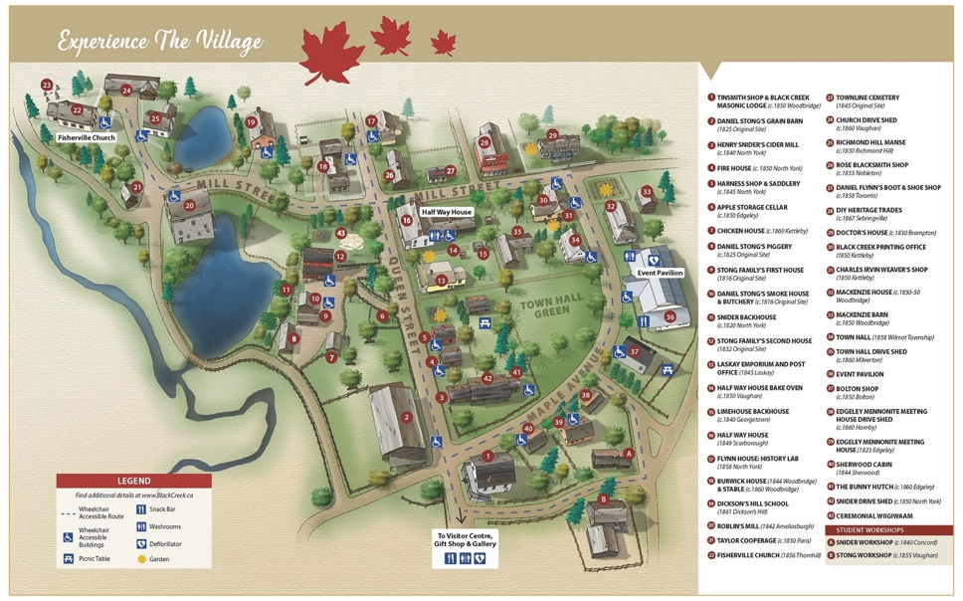

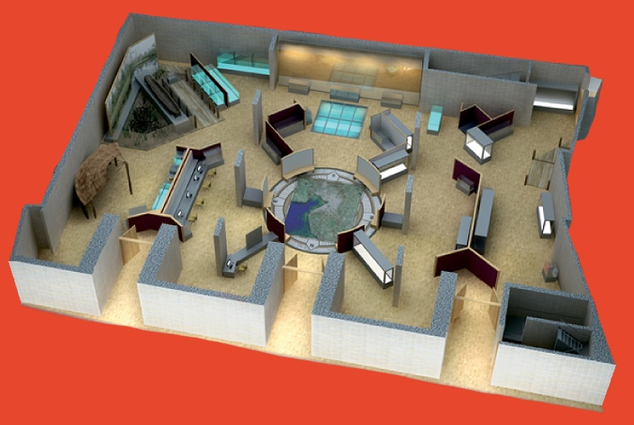

**Timeline of Village Development.** The interactive timeline of the founding and development of BCPV will showcase key milestones for the museum. Visitors can view images and videos of the relocations of each building to the current site, as well as get a sense of how lengthy the process of moving heritage buildings is and how simple buildings and artifacts can be turned into a functioning live museum. This display will help visitors grasp BCPV’s own history and learn about the families who donated their homes and buildings to make this museum a reality.

**Settler Patterns.** The settler patterns visualization will illustrate the migration and settlement patterns of new Ontarians. Using animated flows, arrows, and heat maps with time stamps, this display will show where, when, and why European settlers first came to Ontario. This visualization will provide visitors with an understanding of the demographic and cultural influences of immigrants at the time that helped to shape the Ontario we know today.

**Trade Networks.** This display will map the trade routes used by settlers and the trade networks that connected Ontario in the late 19th century. Visitors will learn about what types of goods were needed at the time, which were rare, and why, as well as where they came from and what modes of transportation were used to get them to Canada and throughout Ontario. Visitors can better understand how trade influenced the economy by tracing the paths of goods, resources, and information. This visualization will include interactive elements such as draggable trade route paths, clickable goods that display their origins and destinations, and animations showing the movement of items along the routes.

**Agriculture and Climate Comparison.** This visualization will allow visitors to explore the changes in agriculture and climate in Ontario over the last 200 years. By selecting different time periods and seasons, visitors can see how agricultural practices have changed and are affected by environmental factors. The tool will include features such as climate data overlays, interactive crop yield graphs, and animations showing changes in farming techniques and climate over time. This visualization will help visitors understand the challenges faced by settlers in sustaining their agricultural practices and how industrialization has influenced our modern agriculture and climate.

Each of these interactive data visualizations is designed to provide a more immersive and engaging experience for museum visitors, enhancing their understanding of the village’s history, culture, and environment. By piloting these visualizations, the study aims to identify the most effective tools for improving learning outcomes and visitor engagement, ultimately informing future exhibit design and technology integration at BCPV.

**Objectives**

The main goal of this study is to evaluate the impact of the addition of interactive data visualizations on visitor engagement, learning, and satisfaction in the heritage museum setting at BCPV. This goal can be broken down into the following four objectives:

1. **Understand Visitor Wants and Expectations:** Gather information on what ticket holders expect to do, see, learn, and experience before their visit to BCPV, as well as which aspects of the museum convinced them to purchase a ticket.
2. **Assess Changes in Visitor Experience:** Measure changes in visitor satisfaction before and after the addition of interactive data visualizations.
3. **Evaluate Learning Outcomes:** Compare the knowledge retention and learning experiences of visitors before and after the addition of interactive data visualizations.
4. **Inform Future Exhibit Design:** Gather information on what visitors would like to see added to the museum in the future and use these findings to inform new exhibits. From this, I will be able to provide museum stakeholders with actionable recommendations for the integration of technology and dynamic data visualizations into BCPV.

This study aims to contribute valuable insights into the impact, use, and role of interactive data visualizations in museum settings, ultimately improving the visitor experience and educational impact of museums and other similar cultural institutions.

**Methods**

This study will use a mixed-methods approach to evaluate the impact of incorporating interactive data visualizations at BCPV on visitor engagement and learning outcomes. Collecting both qualitative and quantitative data will provide a holistic account of visitors’ needs, wants, experiences, and learning before and after data visualizations are incorporated into the history museum setting.

**Participants.** I will recruit a diverse sample of museum visitors to participate in the evaluation of interactive data visualizations at BCPV. A total of 250 participants will be recruited, accounting for about a 20% attrition rate that comes with pre-post designs. The inclusion criteria for this study are those 18 or older who have purchased tickets to visit BCPV in the next 12 months. Participants will be recruited via email when they purchase tickets to complete the pre-visit portion of the study. A second email will be sent after their visit date to the same email inviting them to complete the post-visit portion of the study. Interview recruitment will also be completed via email, requiring participants to have already visited BCPV during the time when the interactive data visualizations were installed.

**Measures.** This study will use surveys, quizzes, and structured interviews to collect data from visitors regarding their experiences at BCPV before and/or after interactive data visualizations were added to selected areas. A pre-visit survey will assess visitor expectations, including their interests and preferences for exhibits. A post-visit survey will assess overall satisfaction and experience in the museum. Results from these surveys will be compared among those who visited before and after the data visualizations were installed. Short quizzes will be used to evaluate learning outcomes, comprehension, and knowledge retention. Items will heavily focus on topics covered by the data visualizations, but include some more general topics as well. Results from these quizzes will be compared among those who visited before and after the data visualizations were installed. Structured interviews will also be conducted to specifically gain insight into how the dynamic visualizations were perceived by visitors, their own reflections on their experience and learning using these visualizations, as well as ease of use and further suggestions for improvement.

**Procedure.** Recruitment will occur on a rolling basis for one year. The interactive data visualizations will be added after four months have passed to ensure sufficient data on visitor experience without any changes to the museum. Participants will be invited to join the study via email when they purchase their tickets, this will include the pre-survey and the call for in-person interviews. A follow-up email will be sent after their visit day, inviting them to complete the post-survey and the learning outcomes quiz.

**Expected Outcomes**

The addition of interactive data visualizations at BCPV is expected to have positive outcomes for both the museum and its patrons:

1. **Increased Engagement:** Visitors will likely spend more time at interactive exhibits, leading to increased engagement with the museum’s content and more time spent at the museum (Pallud, 2017).
2. **Improved Learning Outcomes:** Through presenting information in more interesting and engaging formats, visitors are expected to have better understanding and retention of the new information learned, feeling more satisfied with their visit (Chen et al., 2021)
3. **Positive Visitor Feedback:** Should the addition of interactive data visualizations be successful, positive visitor feedback and satisfaction will increase. The data collected in interviews and surveys regarding visitor expectations, perceptions, and preferences will be used to inform future exhibits and continue to improve the museum, leading to many more positive visitor experiences.

**Discussion**

The findings from this study could have significant implications for museum curation, particularly among history and heritage museums. Through demonstrating the effectiveness of interactive data visualizations in increasing visitor engagement and improving learning outcomes, this research could encourage other museums to adopt similar approaches using technology to display data, rather than relying on text. Using technology to create interactive and engaging exhibits could help museums modernize, remain relevant, and appeal to broader audiences. This is particularly important in the current era, where technology plays a crucial role in our daily lives and is the way we are now accustomed to receiving information.

This study is not without potential challenges. Designing, installing, and implementing these complex dynamic visualizations requires technical expertise and resources. It may be difficult to secure the funding needed to implement these displays and hire the experts needed to execute their design. There may also be challenges in maintaining these displays and ensuring they are in working order every day, as technology can be fickle. There is also a need to ensure that the data visualizations being installed are accessible to all visitors. This may mean recording a narration or voiceover for each display or having staff at the ready to assist those with differing accessibility needs. Finally, these data visualizations may be difficult to design as visitors will be coming from diverse backgrounds with varying levels of comfort with technology, education, and interest in history. Determining an audience to tailor these displays will require further research beyond the scope of the proposed study.

**Conclusion**

Integrating interactive data visualizations into museum settings has the potential to significantly improve the museum experience. In addressing common complaints about traditional exhibits and providing a more engaging presentation of information, the implementation of dynamic visualizations can increase visitor engagement and improve learning outcomes. The proposed study at BCPV aims to provide evidence of the positive effect of this approach, contributing to the modernization of the museum sector.

**References**

Black Creek Pioneer Village. https://blackcreek.ca/

Bekele, M. K., Town, C., Pierdicca, R., Frontoni, E., & Malinverni, E. S. (2018). A survey of augmented, virtual, and mixed reality for cultural heritage. *Journal on Computing and Cultural Heritage*, *11*(2), 1–36. https://doi.org/https://doi.org/10.1145/3145534

Bruno, F., Bruno, S., De Sensi, G., Luchi, M. L., Mancuso, S., & Muzzupappa, M. (2010). From 3D reconstruction to virtual reality: A complete methodology for digital archaeological exhibition. *Journal of Cultural Heritage*, *11*(1), 42-49.

Chen, S., Duan, A., & Wang, J. (2021). Using Digital Technologies in Museum Learning Activities to Enhance Learning Experience: A Systematic Review. *Bulletin of the Technical Committee on Learning Technology*, *21*(2), 32–36.

*Interactive map*. Lincoln Museum. https://www.lincolnmuseum.com/visiting-us/interactive-map

Kang, Y., & Yang, K. C. (2020). Employing digital reality technologies in art exhibitions and museums: A global survey of best practices and implications. In *Virtual and augmented reality in education, art, and museums* (pp. 139-161). IGI Global.

Mailhot, J. (2021). Visualizing the Future of Collections: How to Make Data Visualization Accessible and Useful for Managing Collections and Museums. *Collections*, *17*(4), 478-501.

Mason, M. (2020). The elements of visitor experience in Post-Digital Museum Design. *Design Principles and Practices: An International Journal—Annual Review*, *14*(1), 1–14. https://doi.org/10.18848/1833-1874/cgp/v14i01/1-14

Norman, D. A. (2009). The Way I See It. Systems thinking: a product is more than the product. *Interactions*, *16*(5), 52–54. https://doi.org/10.1145/1572626.1572637

Pallud, J. (2017). Impact of interactive technologies on stimulating learning experiences in a museum. *Information & Management*, *54*(4), 465–478. https://doi.org/10.1016/j.im.2016.10.004

Pantile, D., Frasca, R., Mazzeo, A., Ventrella, M., & Verreschi, G. (2016, November). New technologies and tools for immersive and engaging visitor experiences in museums: The evolution of the visit-actor in next-generation storytelling, through augmented and virtual reality, and immersive 3d projections. In *2016 12th International conference on signal-image technology & internet-based systems (SITIS)* (pp. 463-467). IEEE.

Pine, B. J., & Gilmore, J. (1999). The Experience Economy. *Harvard Business School Press, Boston, Massachusetts*.

Roussou, M., & Katifori, A. (2018). Flow, staging, wayfinding, personalization: Evaluating user experience with Mobile Museum narratives. *Multimodal Technologies and Interaction*, *2*(2), 32. https://doi.org/10.3390/mti2020032

Scott, C. (2006). Museums: Impact and value. *Cultural Trends*, *15*(1), 45–75. https://doi.org/10.1080/09548960600615947

Srinivasan, R., Boast, R., Furner, J., & Becvar, K. M. (2009). Digital Museums and diverse cultural knowledges: Moving past the traditional catalog. *The Information Society*, *25*(4), 265–278. https://doi.org/10.1080/01972240903028714

Trunfio, M., Campana, S., & Magnelli, A. (2020). Measuring the impact of functional and experiential mixed reality elements on a museum visit. *Current Issues in Tourism*, *23*(16), 1990–2008. https://doi.org/https://doi.org/10.1080/13683500.2019.1703914